Uninstalling existing Oracle Client:

Uninstall the 64 bit client first, to uninstall navigate to the Oracle 64 bit home, for example D:\Oracle64Bit\product\12.1.0\client_1\deinstall and run the deinstall.bat file as Administrator.

Once the uninstallation is complete, reboot the machine and delete the Oracle 64 bit folder.

Repeat the same procedure for uninstalling the Oracle 32 bit client and reboot the machine and delete the folder.

Install new version

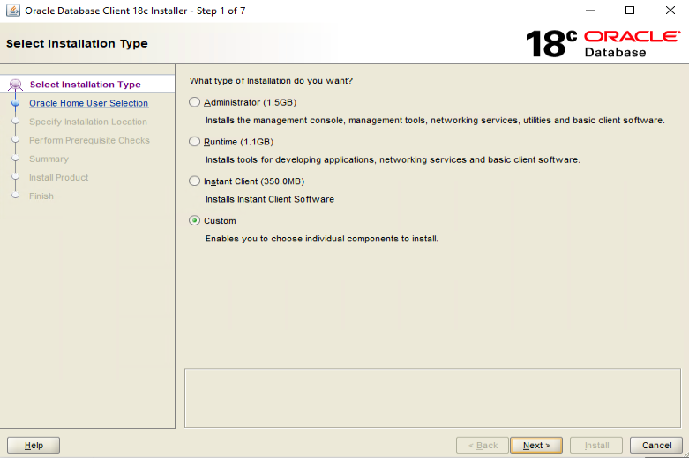

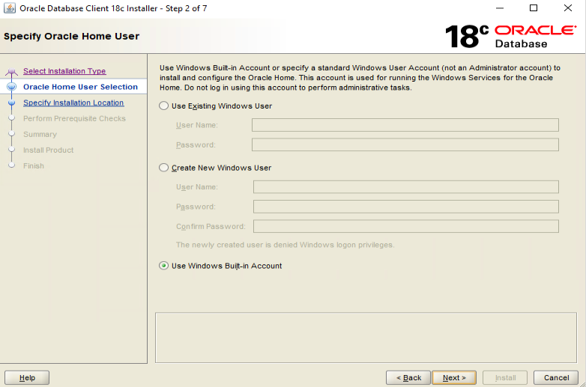

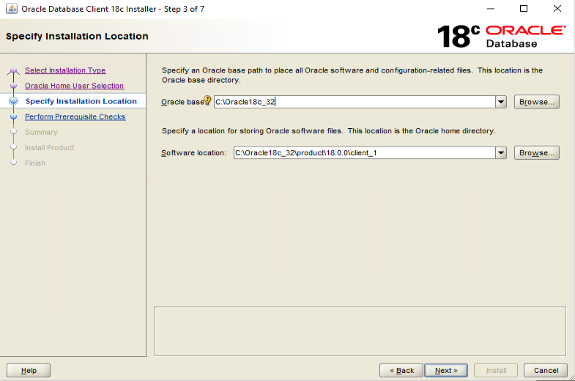

* Oracle SQL Developer is an optional component not required by the Smart 3D software. If installing both the 32 bit and 64 bit clients, SQL Developer is required to be installed only once.

